Project No. 2019-1-DE02-KA202-006099

mes Training Curriculums
INDI4.0 Project Stuttgart | 06/2021 Workshop documents Intellectual Output “IO1”

Manufacturing Execution System
with Siemens TIA Porta
OPC-UA Client Server

UE1 - Installation and setup of an OPC-UA communication between PLC
(Server) and a software application (client)
Communication interfaces between MES and PLC

Learning objective
When you have completed this task
- Have you got to know different interfaces for communication with a PLC?

Problem
Flexible production up to a lot size of one is required of automated production systems today. In order to be able to realize this, tooManufacturing Execution System(MES) used. These systems can, for example, communicate with a PLC and / or at the same time with an ERP system. Different interfaces can be used for communication for this purpose.

Work aids
- Work order
- Theory book and table book
- Tablet
- Smartphone

Work order

Read the following pages carefully and work on the individual tasks at the end.
Timing: A total of 85 minutes
For the completion of the tasks 1-3 - 65 minutes.
For the presentation including discussion of the solution to task 3 in plenary 20 min.

In the previous teaching units you got to know the term and the function of an MES (Manufacturing Execution System) in connection with ﬂ exible production.  In the following teaching units we would like to deal with the communication between a PLC and an MES. Before we start, however, we would like to recall the functionality of an MES again. | 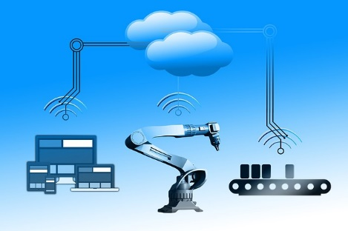  source 1: pixabay.com
1
Check out the link below http://t1p.de/v5mp the video for MES.

The video shows that the MES communicates with a controller (PLC) and tells the respective workstations how the workpiece is to be processed.

Thus, both the MES and the PLC must have interfaces that can be used for communication and thus for data exchange.

The interfaces for communication are distinguished as follows:

- Standardized interfaces: Standardized unified communication interfaces for the communication of any different devices.
- Proprietary interfaces: Specific communication interfaces that are used for communication between special devices.

2 | Analyze the interfaces listed below with the help of the Internet and assign the interfaces to the terms standardized interface or proprietary interface.  Interfaces: OPC UA, ODBC, IO-Link, DCOM, HTTP, RS-232  Result of the internet research:  Standardized interfaces Proprietary interfaces
Now check your results of work order 2 with the sample solution in the solution folder and then edit work order 3 on the back of this worksheet.

3 | In partner work, create a learning snack (knowledge test - https://www.learningsnacks.de) with at least 20 questions and the corresponding answers for the interfaces OPC, OPC UA, ODBC and TCP / IP. Please note that each interface appears equally in the questions. You can find an example of this on the worksheet below. Then share your learning snack with your classmates using the usual means of communication in the class.
example
You can find an example of a learning snack via the adjacent QR code.

a notice
We then want to agree on a learning snack with at least 30 questions. In the next class test, the teacher will use some of the questions.

"The European Commission support for the production of this publication does not constitute an endorsement of the contents which reflects the views only of the authors, and the Commission cannot be held responsible for any use which may be made of the information contained therein."

Source: own drawing

